Kyle Matheson T00153296

COMP1131 Assignment 5 Arrays and Recursion

Question 1: ArrayOps



Test: 5

Test: 10

Test: 103 \*truncated test results for display purposes

Test: 3

Test : 65535 \*truncated test results for display purposes

Test for valid input:

Question 2: Deck of Cards



Test Run #1:

Deck Contains:

Ace of Diamonds

2 of Diamonds

3 of Diamonds

4 of Diamonds

5 of Diamonds

6 of Diamonds

7 of Diamonds

8 of Diamonds

9 of Diamonds

10 of Diamonds

Jack of Diamonds

Queen of Diamonds

King of Diamonds

Ace of Clubs

2 of Clubs

3 of Clubs

4 of Clubs

5 of Clubs

6 of Clubs

7 of Clubs

8 of Clubs

9 of Clubs

10 of Clubs

Jack of Clubs

Queen of Clubs

King of Clubs

Ace of Hearts

2 of Hearts

3 of Hearts

4 of Hearts

5 of Hearts

6 of Hearts

7 of Hearts

8 of Hearts

9 of Hearts

10 of Hearts

Jack of Hearts

Queen of Hearts

King of Hearts

Ace of Spades

2 of Spades

3 of Spades

4 of Spades

5 of Spades

6 of Spades

7 of Spades

8 of Spades

9 of Spades

10 of Spades

Jack of Spades

Queen of Spades

King of Spades

Deck Contains:

8 of Spades

King of Spades

3 of Diamonds

5 of Diamonds

6 of Spades

2 of Diamonds

5 of Spades

Ace of Hearts

5 of Clubs

King of Clubs

8 of Diamonds

10 of Diamonds

7 of Spades

King of Hearts

8 of Clubs

10 of Spades

6 of Clubs

2 of Clubs

3 of Hearts

4 of Clubs

2 of Hearts

9 of Diamonds

8 of Hearts

Ace of Diamonds

10 of Hearts

3 of Clubs

4 of Hearts

9 of Spades

Queen of Clubs

7 of Hearts

9 of Clubs

7 of Diamonds

Queen of Diamonds

Ace of Spades

Ace of Clubs

Queen of Spades

6 of Diamonds

4 of Diamonds

5 of Hearts

Jack of Spades

2 of Spades

4 of Spades

Queen of Hearts

King of Diamonds

10 of Clubs

7 of Clubs

Jack of Diamonds

6 of Hearts

3 of Spades

Jack of Hearts

Jack of Clubs

9 of Hearts

8 of Spades

Remaining Cards: 51

King of Spades

Remaining Cards: 50

3 of Diamonds

Remaining Cards: 49

5 of Diamonds

Remaining Cards: 48

6 of Spades

Remaining Cards: 47

2 of Diamonds

Remaining Cards: 46

5 of Spades

Remaining Cards: 45

Ace of Hearts

Remaining Cards: 44

5 of Clubs

Remaining Cards: 43

King of Clubs

Remaining Cards: 42

8 of Diamonds

Remaining Cards: 41

10 of Diamonds

Remaining Cards: 40

7 of Spades

Remaining Cards: 39

King of Hearts

Remaining Cards: 38

8 of Clubs

Remaining Cards: 37

10 of Spades

Remaining Cards: 36

6 of Clubs

Remaining Cards: 35

2 of Clubs

Remaining Cards: 34

3 of Hearts

Remaining Cards: 33

4 of Clubs

Remaining Cards: 32

2 of Hearts

Remaining Cards: 31

9 of Diamonds

Remaining Cards: 30

8 of Hearts

Remaining Cards: 29

Ace of Diamonds

Remaining Cards: 28

10 of Hearts

Remaining Cards: 27

3 of Clubs

Remaining Cards: 26

4 of Hearts

Remaining Cards: 25

9 of Spades

Remaining Cards: 24

Queen of Clubs

Remaining Cards: 23

7 of Hearts

Remaining Cards: 22

9 of Clubs

Remaining Cards: 21

7 of Diamonds

Remaining Cards: 20

Queen of Diamonds

Remaining Cards: 19

Ace of Spades

Remaining Cards: 18

Ace of Clubs

Remaining Cards: 17

Queen of Spades

Remaining Cards: 16

6 of Diamonds

Remaining Cards: 15

4 of Diamonds

Remaining Cards: 14

5 of Hearts

Remaining Cards: 13

Jack of Spades

Remaining Cards: 12

2 of Spades

Remaining Cards: 11

4 of Spades

Remaining Cards: 10

Queen of Hearts

Remaining Cards: 9

King of Diamonds

Remaining Cards: 8

10 of Clubs

Remaining Cards: 7

7 of Clubs

Remaining Cards: 6

Jack of Diamonds

Remaining Cards: 5

6 of Hearts

Remaining Cards: 4

3 of Spades

Remaining Cards: 3

Jack of Hearts

Remaining Cards: 2

Jack of Clubs

Remaining Cards: 1

9 of Hearts

No remaining cards

No remaining cards

No remaining cards

Process finished with exit code 0

Test Run #2:

Deck Contains:

Ace of Diamonds

2 of Diamonds

3 of Diamonds

4 of Diamonds

5 of Diamonds

6 of Diamonds

7 of Diamonds

8 of Diamonds

9 of Diamonds

10 of Diamonds

Jack of Diamonds

Queen of Diamonds

King of Diamonds

Ace of Clubs

2 of Clubs

3 of Clubs

4 of Clubs

5 of Clubs

6 of Clubs

7 of Clubs

8 of Clubs

9 of Clubs

10 of Clubs

Jack of Clubs

Queen of Clubs

King of Clubs

Ace of Hearts

2 of Hearts

3 of Hearts

4 of Hearts

5 of Hearts

6 of Hearts

7 of Hearts

8 of Hearts

9 of Hearts

10 of Hearts

Jack of Hearts

Queen of Hearts

King of Hearts

Ace of Spades

2 of Spades

3 of Spades

4 of Spades

5 of Spades

6 of Spades

7 of Spades

8 of Spades

9 of Spades

10 of Spades

Jack of Spades

Queen of Spades

King of Spades

Deck Contains:

9 of Diamonds

Queen of Diamonds

Queen of Clubs

5 of Spades

8 of Clubs

9 of Clubs

Ace of Clubs

Queen of Spades

Jack of Hearts

3 of Hearts

10 of Clubs

8 of Diamonds

Jack of Spades

5 of Hearts

King of Hearts

Jack of Diamonds

2 of Clubs

6 of Spades

2 of Hearts

4 of Clubs

4 of Hearts

King of Diamonds

5 of Clubs

10 of Hearts

Jack of Clubs

6 of Clubs

4 of Diamonds

9 of Spades

9 of Hearts

Ace of Diamonds

8 of Spades

4 of Spades

7 of Diamonds

King of Spades

7 of Clubs

Ace of Hearts

Ace of Spades

6 of Diamonds

3 of Clubs

King of Clubs

10 of Spades

3 of Diamonds

2 of Spades

7 of Spades

3 of Spades

8 of Hearts

Queen of Hearts

2 of Diamonds

7 of Hearts

10 of Diamonds

5 of Diamonds

6 of Hearts

9 of Diamonds

Remaining Cards: 51

Queen of Diamonds

Remaining Cards: 50

Queen of Clubs

Remaining Cards: 49

5 of Spades

Remaining Cards: 48

8 of Clubs

Remaining Cards: 47

9 of Clubs

Remaining Cards: 46

Ace of Clubs

Remaining Cards: 45

Queen of Spades

Remaining Cards: 44

Jack of Hearts

Remaining Cards: 43

3 of Hearts

Remaining Cards: 42

10 of Clubs

Remaining Cards: 41

8 of Diamonds

Remaining Cards: 40

Jack of Spades

Remaining Cards: 39

5 of Hearts

Remaining Cards: 38

King of Hearts

Remaining Cards: 37

Jack of Diamonds

Remaining Cards: 36

2 of Clubs

Remaining Cards: 35

6 of Spades

Remaining Cards: 34

2 of Hearts

Remaining Cards: 33

4 of Clubs

Remaining Cards: 32

4 of Hearts

Remaining Cards: 31

King of Diamonds

Remaining Cards: 30

5 of Clubs

Remaining Cards: 29

10 of Hearts

Remaining Cards: 28

Jack of Clubs

Remaining Cards: 27

6 of Clubs

Remaining Cards: 26

4 of Diamonds

Remaining Cards: 25

9 of Spades

Remaining Cards: 24

9 of Hearts

Remaining Cards: 23

Ace of Diamonds

Remaining Cards: 22

8 of Spades

Remaining Cards: 21

4 of Spades

Remaining Cards: 20

7 of Diamonds

Remaining Cards: 19

King of Spades

Remaining Cards: 18

7 of Clubs

Remaining Cards: 17

Ace of Hearts

Remaining Cards: 16

Ace of Spades

Remaining Cards: 15

6 of Diamonds

Remaining Cards: 14

3 of Clubs

Remaining Cards: 13

King of Clubs

Remaining Cards: 12

10 of Spades

Remaining Cards: 11

3 of Diamonds

Remaining Cards: 10

2 of Spades

Remaining Cards: 9

7 of Spades

Remaining Cards: 8

3 of Spades

Remaining Cards: 7

8 of Hearts

Remaining Cards: 6

Queen of Hearts

Remaining Cards: 5

2 of Diamonds

Remaining Cards: 4

7 of Hearts

Remaining Cards: 3

10 of Diamonds

Remaining Cards: 2

5 of Diamonds

Remaining Cards: 1

6 of Hearts

No remaining cards

No remaining cards

No remaining cards

Process finished with exit code 0

Question 3: Pascal’s Triangle



Test1:

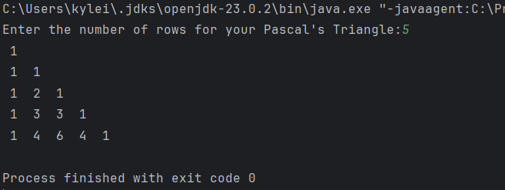

Test2:

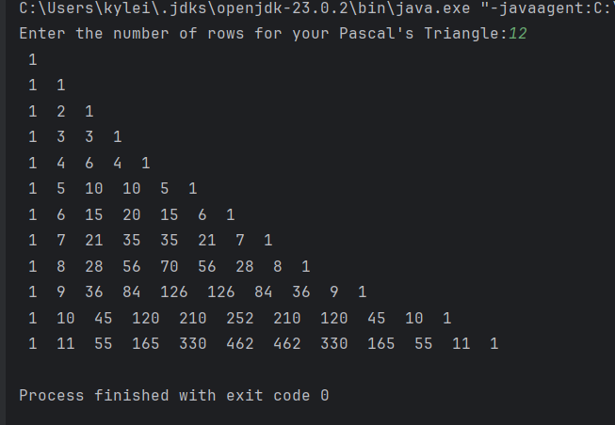

Test3:

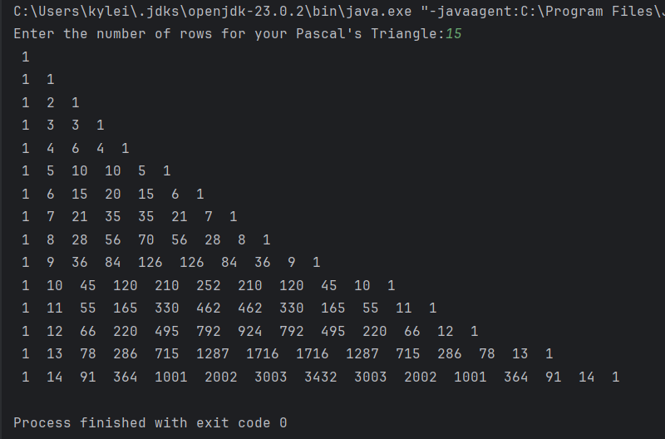

Stress Test:

